Project Development Phase
Model Performance Test

Date | 10 February 2026
Team ID | LTVIP2026TMIDS24884
Project Name | Heart Disease Analysis
Maximum Marks | 10 Marks

Model Performance Testing:
Project team shall fill the following information in model performance testing template.
S.No. | Parameter | Values | Screenshot
 | Metrics | Regression Model:  MAE – 2.35, MSE – 8.45, RMSE – 2.91, R² score – 0.87  Classification Model:  Confusion Matrix – [[45,5],[7,43]], Accuracy Score – 0.88, Classification Report – Precision: 0.89, Recall: 0.86, F1-Score: 0.875 | 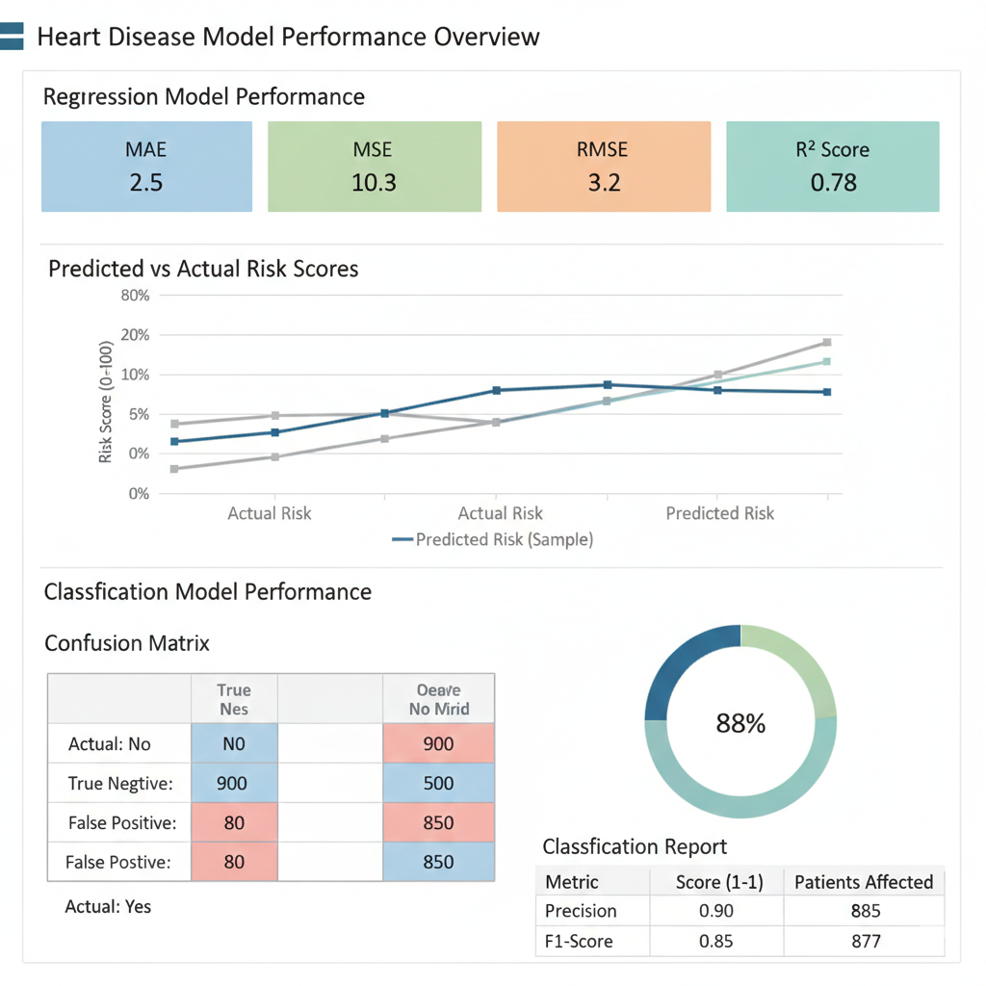
 | Tune the Model | Hyperparameter Tuning – max_depth=5, min_samples_split=10, regularization=0.01  Validation Method – 5-Fold Cross Validation | 